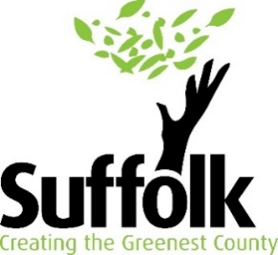
Bulk Buying Guidance

Bulk buying refers to the purchase of multiple quantities of product in exchange for a lower price per unit.
Benefits:
- Buying efficiency
- Cheaper pricing
- Buying according to demand
- Discounts
- Recurring delivery
- Minimises environmental impact on packaging and transporting goods in bulk
- Increases buying power
Please watch the video link below as it provides a useful starting point:
https://www.youtube.com/watch?v=RQfnTxR9hKI

Checklist for setting up a community buying group:

- What can we buy better as a group than we could as individuals (it would be cheaper or more convenient, or we could pool our knowledge about how to buy it)?

- Have we worked out if there are enough people to buy what we want to buy, and minimum price we can buy it for?

- Have we worked out what resources we need (do we need storage, admin, finance etc)?

- Have we considered how we can find these resources? Could we get things for free or low cost?

- Have we worked out what our costs will be?

- Have we found out what kind of advice and support may be available to help us?

- Have we found suppliers for what we want to buy from and got 3 quotes?

- Have we decided how we want the group to operate? Do we need to decide on formal roles and ways of working? Do we need a legal structure? (non-refundable deposit option etc) Do we need a bank account?

- How are we going to market and promote what we are doing?

- Have we investigated how the law might affect our group (especially if it’s running on lines that are more like a business)?

- What local venues can we use for storage and collection?

- What would we do with left over materials or items that are not collected?

Useful Links:
Guide for Community Buying Groups (publishing.service.gov.uk)
https://www.cse.org.uk/news/view/1853
Bulk buy schemes: community discounts for energy efficiency | Centre for Sustainable Energy (cse.org.uk)

